Exercise 1-4 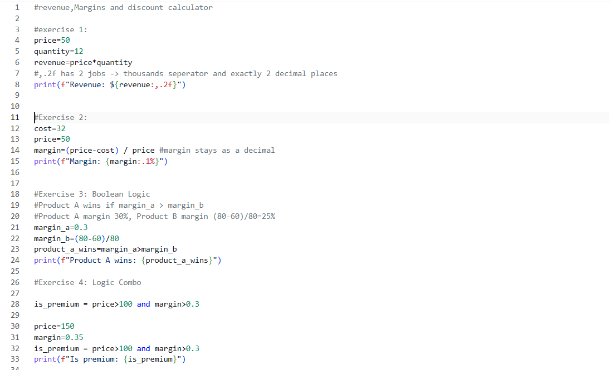

5. 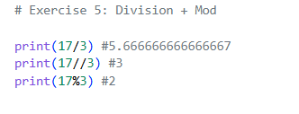
6. 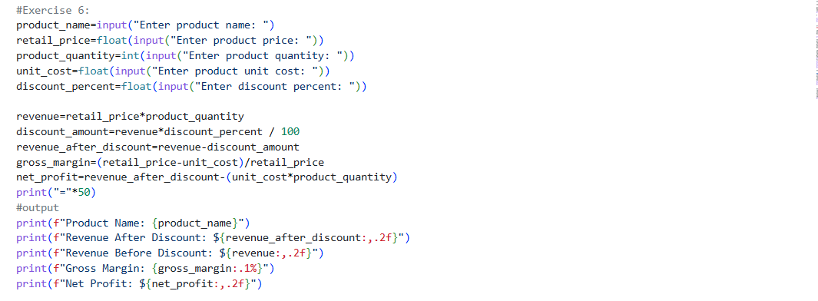
7. 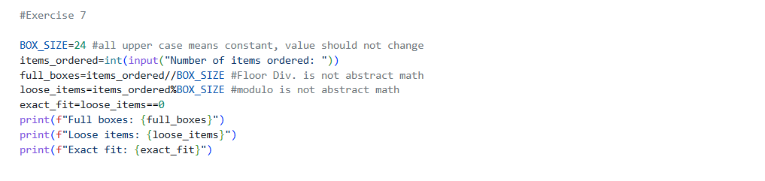

Stretch A. 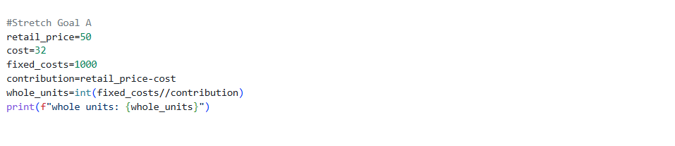

Stretch Goal B.
retail_price=50
cost=24
quantity=22
total_profit=retail_price-cost*quantity = -478
total_profit=(retail_price-cost)*quantity = 572
because we multiplied quantity by cost before taking it away from retail price we end with a negative number where with parenthesis we could of got the correct profit

#wrong process 2
revenue=1000
discount_pct = 20
discounted_rev = revenue * 1-discount_pct/100 = 999.8
discounted_rev = revenue * (1-discount_pct/100) =800
because we did not get the discount percentage first we ended up subtracting 0.2 from 1000 which is way off the answer we need.

#wrong process 3
margin_b=80-60/80 =79.25
margin_b=(80-60)/80 =1/4
you get a very high number without using parenthesis which is way off what you need.

#wrong process 4
entry=10
exit_price=15
shares=100
profit=entry-exit_price*shares =-140
profit=(exit_price-entry)*shares =500
when not using pmdas you end up with a negative number to show profit when you actually have a profit

#wrong process 5
entry=19
exit_price=7
shares=100
loss=entry-exit_price*shares =-681
loss=(entry-exit_price)*shares = 1200

the negative number does not actually show loss because you cant owe more than you put into the system and can only owe how much you lose

